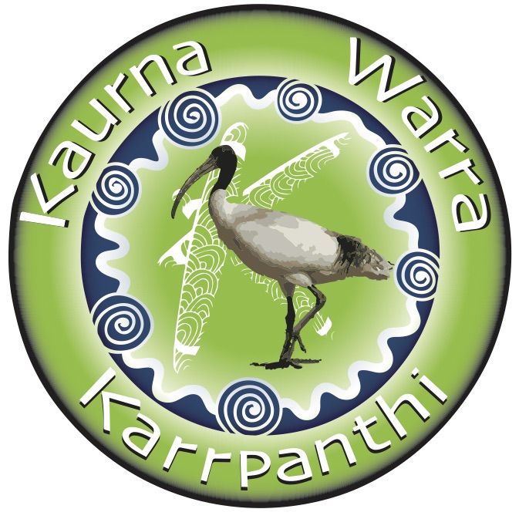
Kaurna Warra Karrpanthi
Chair Person- Alison Denee
Tauondi Aboriginal College
P.O Box 409 Port Adelaide SA 5015
Tel: (08) 8240 0300
Fax: (08) 8240 0786
Email: admin@kwk.org.au

Dale Sutton
Team Leader Engagement, Grants and Events
City of Onkaparinga

01/08/21

Dear Dale,

City of Onkaparinga – Cultural Permission to use Niipu-niipu Wama ‘Friendship Park’ for naming and/or promotion

Kaurna Warra Karrpanthi (KWK) is the leading group dedicated to Kaurna language revitalisation and maintenance process. The traditional lands and language of the Kaurna people include the Adelaide Plains of South Australia.
Kaurna Warra Karrpanthi confirm that the group was consulted and give their cultural consent for City of Onkaparinga to use Niipu-niipu Wama for park name.
KWK understands that City of Onkaparinga may promote and market the naming of Niipu-niipu Wama in the media across Australia and Internationally.
KWK consents to City of Onkaparinga using the Niipu-niipu Wama for the purpose described above.

City of Onkaparinga will be liable to relay and/or utilise the correct information provided by KWK.

KWK understands City of Onkaparinga will acknowledge the source of the word, and keep KWK informed if it wants to use the name in any other way.
request and an invoice.

Yours sincerely,
Taylor Power
On behalf of Kaurna Warra Karrpanthi

