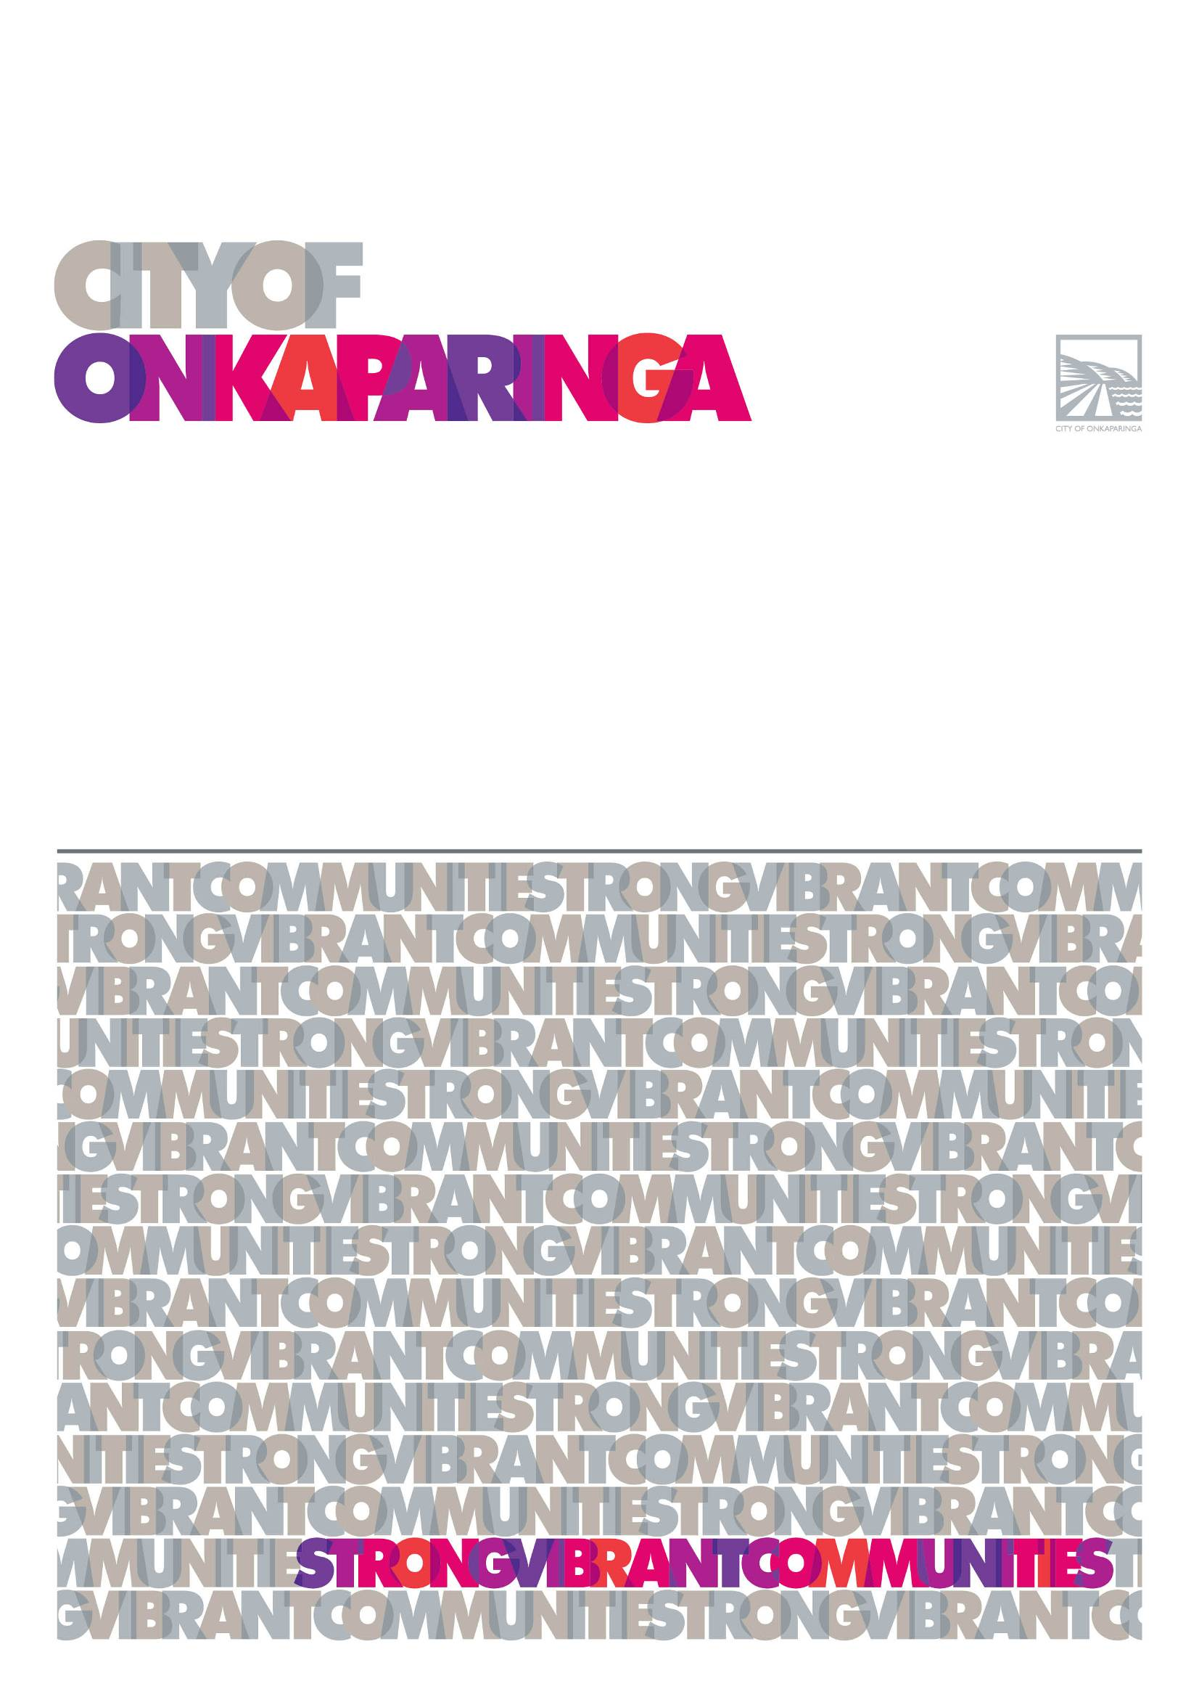
Ina
age 1

2019 Expression of Interest for
Foreshore and Coastal Activation

GUIDELINES

APPLICATION FORM
COMMUNITY EVENTS & CAROLS
Applications close 5pm Wednesday 11 March 2015

Background

As part of our Community Plan 2035, we are committed to realising the vision of our region being recognised as a thriving arts and events hub and tourism destination. Enabling activations along our foreshore and coastal areas is one of the key ways we are working to achieve this goal.

The City of Onkaparinga boasts some of South Australia’s most spectacular beach scenery and provides an ideal setting for activation activities that expand the business landscape within the region, increase visitation as well as promote the local economy.

In recent years, there has been a growing demand from local business and external organisations to provide activation activities for locals and visitors to enjoy, in particular along our foreshore and coastal areas.

The City of Onkaparinga is seeking proposals from interested parties in activating our foreshore and coastal areas for the 2019/20 summer period and with potential to continue for up to a two (2) year period, through an Expression of Interest (EOI) process.

Expression of Interest & Assessment Process

Expressions of Interest open: Wednesday 5 June 2019
Expressions of Interest close: 5pm, Friday 28 June 2019
Assessment of proposals: Early July 2019
Public consultation on proposals (if required): Late July / Early August 2019
Council decision: 17 September 2019
Applicants notified of the outcome: 18 September 2019
50% allocation of funding support: Late September 2019
Remaining 50% allocation of funding support: Upon completion of the activation and receipt of acquittal

Assessment Criteria

The City of Onkaparinga is specifically seeking proposals that identify opportunities for entertainment, food, beverage and tourism in addition to those that have the potential to become iconic activations within the region.

Expressions of interest will also be assessed based on the proposed activation’s potential to:

- Provide significant economic benefits, such as through increased visitor spending, encouraging uptake of overnight accommodation as well as partnering with local businesses to stimulate local business activity and/or employment.
- Attract people from across the region as well as visitors from interstate and overseas.
- Promote tourism in our city and the Fleurieu Peninsula.
- Provide benefits to the wider community by encouraging opportunities for community participation and development.
- Minimise the impact to the environment, including local fauna and flora.
- Minimise waste and encourage recycling.
- Encourage the ongoing sustainability of the activation through securing cash and in-kind support from other sources.
Potential Sites for Activation

The City of Onkaparinga is particularly interested in proposals that seek to activate our foreshore and coastal areas. Sites that have been identified as potentially suitable for activations include:

- Christies Beach (Rotary Park and foreshore areas)
- Port Noarlunga (Sauerbier House)
- Moana (Esplanade / Nashwauk Crescent Reserve)
- Aldinga Beach (Silver Sands and Snapper Point)

Applicants can choose one or more of the above locations as their preferred site for their proposed activation, however, Expressions of Interest for sites located anywhere within the City of Onkaparinga and for other times of year will also be considered.

Funding Support

Please be advised that Council funding may be available to eligible applications.

Applicants seeking funding support must complete all sections within the Expression of Interest Application Form, attach an income and expenditure statement for the proposed activation to their application and state the amount they are requesting from Council. Please note, no more than 50% of the total activation cost can be requested.

Costs Not Eligible for Funding

The following costs are not eligible for funding support from the Council:

- Costs relating to activations that commence or take place prior to October 2019.
- Reimbursement for any money already spent.
- Recurrent operating costs (in particular costs not directly related to the activation).
- Purchase of equipment or materials not directly related to the activation.

Allocation of Funding

Please be advised that fifty percent (50%) of funds awarded will be paid following notification of successful application and the remaining fifty percent (50%) of funds will be distributed upon completion of the activation and receipt of acquittal.

Funding Terms and Conditions

Applicants must:
- Use any council funding for the approved activation(s) as described in the Expression of Interest Application Form.
- Obtain written approval from the Council for any requested changes to the activation as described in the Expression of Interest Application Form.
- Obtain any relevant approvals including liquor licenses etc.
- Observe and comply with recognised Australian Standards and must observe any relevant federal, state or local government regulations or guidelines (environmental protection, noise control, traffic management etc).
- Obtain all necessary insurances and ensure that the City of Onkaparinga is not held liable for any matter arising out of the activation(s).
- Provide a current Public Liability Insurance Certificate (minimum $20 million) noting City of Onkaparinga as an interested party.
- Deal with any complaints received relating to the activation (planning and delivery).
- Ensure that safe management systems are put in place for the planning and delivery of the activation(s). This includes undertaking a risk assessment and ensuring that key individuals involved with delivering the activation(s) are aware of the identified risks and the related mitigation strategies.
- Minimise waste and encourage recycling (information is available on our waste and recycling webpage at www.onkaparingacity.com/onka/living_here/waste_recycling)
- For ticketed activations or where an entry fee applies, provide the Council with two (2) tickets/free passes to the activation that will be used for assessment purposes.

How to Apply

Submit your Expression of Interest Application Form (and supporting documentation) via email by the closing date to:

Monique Palumbo
Economic Growth Officer
E: monique.palumbo@onkaparinga.sa.gov.au

An email confirmation will be sent to applicants once their Expression of Interest Application Form (and supporting documentation) has been received. If you do not receive an email confirmation within 48 hours of submission, please call 8384 0643.

Please note: late applications will not be accepted.

Enquiries

For any enquiries, please contact:

Monique Palumbo
Economic Growth Officer
P: 08 8384 0643
E: monique.palumbo@onkaparinga.sa.gov.au

